Activity8.java

Program:

class CustomException extends Exception {

private String message = null;

public CustomException(String message) {

this.message = message;

}

@Override

public String getMessage() {

return message;

}

}

public class Activity8 {

public static void main(String[] a){

try {

// Method call with correct input

Activity8.exceptionTest("Will print to console");

// Method call with incorrect input

Activity8.exceptionTest(null); // Exception is thrown here

Activity8.exceptionTest("Won't execute");

} catch(CustomException mae) {

System.out.println("Inside catch block: " + mae.getMessage());

}

}

static void exceptionTest(String str) throws CustomException {

if(str == null) {

throw new CustomException("String value is null");

} else {

System.out.println(str);

}

}

}

Output:

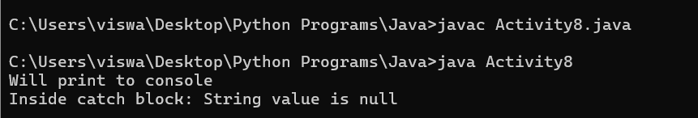

Activity9

Program:

import java.util.ArrayList;

public class Activity9 {

public static void main(String[] args) {

ArrayList<String> myList = new ArrayList<String>();

myList.add("Apple");

myList.add("Mango");

myList.add("Orange");

myList.add(3, "Grapes");

myList.add(1, "Papaya");

System.out.println("Print all the objects:");

for(String s:myList){

System.out.println(s);

}

System.out.println("3rd element in the list is: " + myList.get(2));

System.out.println("Is pineapple in the list: " + myList.contains("pineapple"));

System.out.println("Size of ArrayList: " + myList.size());

myList.remove("grapes");

System.out.println("New Size of ArrayList: " + myList.size());

}

}

Output:

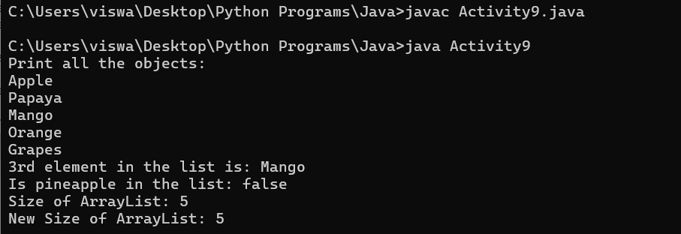

Activity10

Program:

import java.util.HashSet;

public class Activity10 {

public static void main(String[] args) {

HashSet<String> h = new HashSet<String>();

h.add("A");

h.add("B");

h.add("C");

h.add("N");

h.add("M");

h.add("X");

System.out.println("Original HashSet: " + h);

System.out.println("Size of HashSet: " + h.size());

System.out.println("Removing C from HashSet: " + h.remove("C"));

if(h.remove("P")) {

System.out.println("P removed from the Set");

} else {

System.out.println("P is not present in the Set");

}

System.out.println("Validating if M is present: " + h.contains("M"));

System.out.println("Updated HashSet: " + h);

}

}

Output:

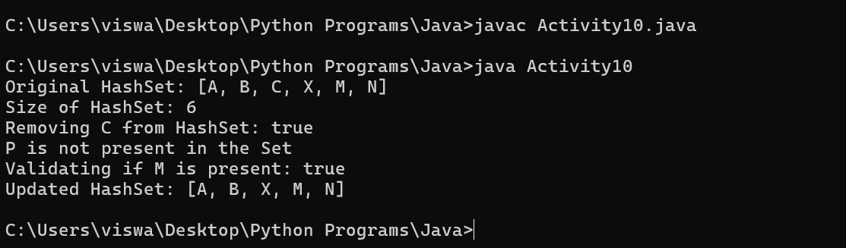

Activity11

Program:

import java.util.HashMap;

public class Activity11 {

public static void main(String[] args) {

HashMap<Integer, String> hmap = new HashMap<Integer, String>();

hmap.put(1, "Red");

hmap.put(2, "Green");

hmap.put(3, "Blue");

hmap.put(4, "Yellow");

hmap.put(5, "Orange");

System.out.println("The Original map: " + hmap);

hmap.remove(3);

System.out.println("After removing: " + hmap);

if(hmap.containsValue("Yellow")) {

System.out.println("Yellow exists in the Map");

} else {

System.out.println("Yellow does not exist in the Map");

}

System.out.println("Number of pairs in the Map is: " + hmap.size());

}

}

Output:

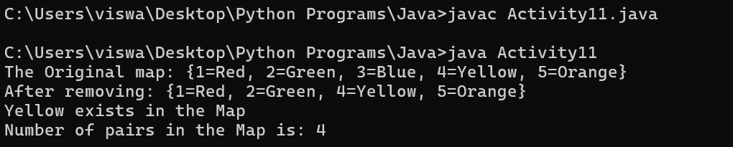

Activity12

Program:

import java.util.\*;

interface Addable {

int add(int a, int b);

}

public class Activity12 {

public static void main(String[] args) {

Addable ad1 = (a, b) -> (a + b);

System.out.println(ad1.add(10, 20));

Addable ad2 = (int a, int b) -> {

return (a + b);

};

System.out.println(ad2.add(100, 200));

}

}

Output:

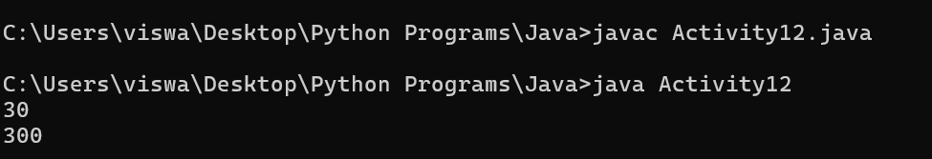

Activity13

Program:

import java.util.\*;

public class Activity13 {

public static void main(String[] args) {

Scanner scan = new Scanner(System.in);

ArrayList<Integer> list = new ArrayList<Integer>();

Random indexGen = new Random();

System.out.print("Enter integers please ");

System.out.println("(EOF or non-integer to terminate): ");

while(scan.hasNextInt()) {

list.add(scan.nextInt());

}

Integer nums[] = list.toArray(new Integer[0]);

int index = indexGen.nextInt(nums.length);

System.out.println("Index value generated: " + index);

System.out.println("Value in arary at generated index: " + nums[index]);

scan.close();

}

}

Output:

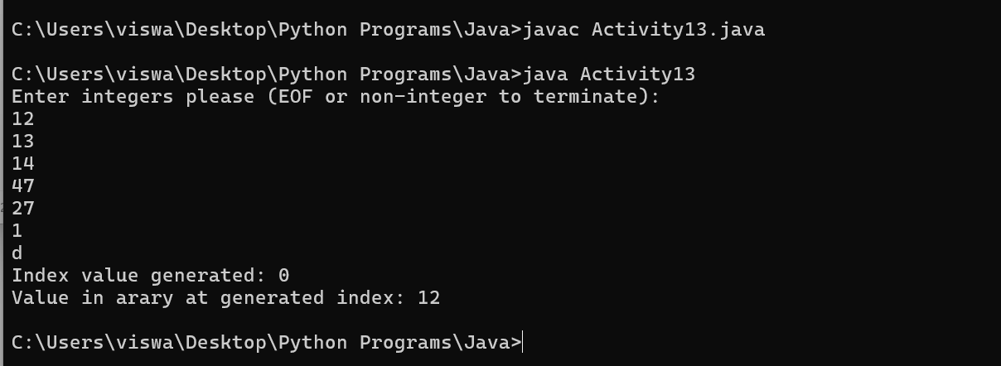

Activity14